The TD 110 tool breakage detector from HEIDENHAIN:
Retrofit, save more time, add more process reliability

Perform on-machine tool breakage inspection that seamlessly integrates into your automated processes. The HEIDENHAIN TD 110 tool breakage detector provides two essential sustainability benefits: significant time savings and minimized scrap, resulting in greater productivity from the very first part.

The TD 110 improves the process reliability of your automated processes on the fly by detecting broken tools. This prevents damage in subsequent machining operations. As broken tools pass by on their way between the tool magazine and work envelope, the TD 110 detects these breaks and prevents such tools from being used again. This compact and robust sensor can be retrofit to the workspace of any machine tool in close proximity to the machining table. Installing a TD 110 on a machine tool with a HEIDENHAIN control takes only four to five hours; this investment pays for itself after just 3000 tool inspections.

The TD 110 tool breakage detector inspects tools with a diameter of at least 0.4 mm and performs non-contact breakage detection starting with a length change of 2 mm. This happens inside the machine envelope with the spindle rotating at its operating speed. This considerably increases the process reliability and, thanks to path optimization, shaves up to six seconds off of every inspection compared with conventional laser systems. The signals of the TD 110 are sent to the control via the touch-probe interface. The control then triggers a machine message, an NC stop or a user-defined reaction, such as a message to StateMonitor, the MDA software from HEIDENHAIN.

The time and cost benefits during tool changes are considerable. And because the TD 110 operates without compressed air, its carbon footprint is small. Mounting is thus greatly simplified. Without the need for compressed air hoses or filter units, installation comes down to connecting a single cable carrying both power and communication. And thanks to its inductive measurement technology, the TD 110 is maintenance-free.

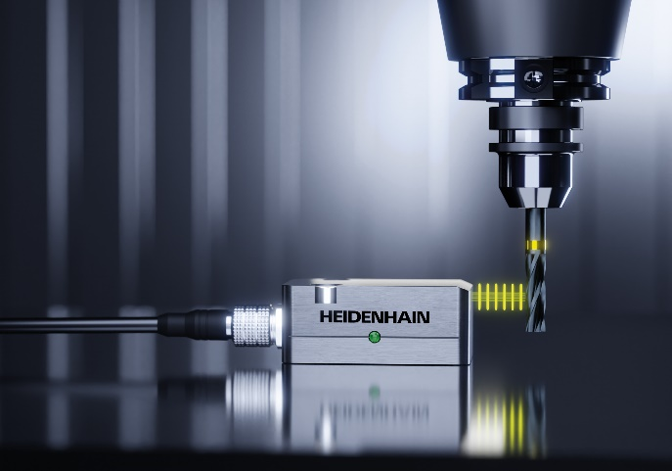 | Save 6 seconds during each tool breakage inspection: the TD 110 tool breakage detector from HEIDENHAIN provides fast, on-machine inspection, even for microtools

HEIDENHAIN at AMB, Sept. 10 to 14, 2024

Main booth:  Hall 2, Booth 2D10 | TNC Club:  Hall 2, Booth 2B03
HEIDENHAIN @ DMG Mori:  Hall 10, Booth 10D10 | Training Exhibit:  East Entrance, Atrium
For more information, visit:  live.heidenhain.com  www.heidenhain.com/tnc7  www.heidenhain.com | Contact person for the trade press:  Ulrich Poestgens  DR. JOHANNES HEIDENHAIN GmbH  Dr.-Johannes-Heidenhain-Straße 5  83301 Traunreut, GERMANY  Tel.: +49 8669 31-4154  poestgens@heidenhain.de

